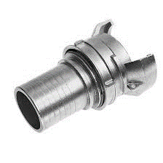

|  |  |  |  |  |  |  |  |
| --- | --- | --- | --- | --- | --- | --- | --- |
|  |  | ALUMINIO | | INOX 316 | | POLIPROP. | |
| **DN 20** | **PM 25** | *30101AL025* | **6.12** | *30101IN025* | **11.87** |  |  |
| **DN 25** | **PM 30** | *30101AL030* | **6.83** | *30101IN030* | **13.66** |  |  |
| **DN 32** | **PM 35** | *30101AL035* | **7.82** | *30101IN035* | **18,71** |  |  |
| **DN 40** | **PM 40** | *30101AL040* | **8.86** | *30101IN040* | **27.14** | *30101PP040* | **10.34** |
| **DN 40** | **PM 45** | *30101AL045* | **10.68** | *30101IN045* | **29.15** |  |  |
| **DN 50** | **PM 50** | *30101AL050* | **13.23** | *30101IN050* | **38.37** | *30101PP050* | **15.15** |
| **DN 50** | **PM 55** | *30101AL055* | **13,82** |  |  |  |  |
| **DN 65** | **PM 65** | *30101AL065* | **17.33** |  |  |  |  |
| **DN 65** | **PM 70** | *30101AL070* | **16.16** | *30101IN070* | **65.58** |  |  |
| **DN 80** | **PM 75** | *30101AL075* | **25.68** | *30101IN075* | **96.72** | *30101PP075* | **22.32** |
| **DN 80** | **PM 80** | *30101AL080* | **26.49** | *30101IN080* | **106.64** |  |  |
| **DN 80** | **PM 90** | *30101AL090* | **24.51** | *30101IN090* | **90.99** | *30101PP090* | **29.02** |
| **DN 100** | **PM 100** | *30101AL100* | **37.72** | *30101IN100* | **151.92** | *30101PP100* | **38.28** |

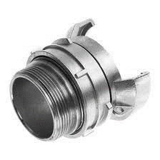

|  |  |  |  |  |  |  |  |
| --- | --- | --- | --- | --- | --- | --- | --- |
|  |  | ALUMINIO | | INOX 316 | | POLIPROP. | |
| **DN 20** | **¾”** | *30103AL020* | **4.42** |  |  |  |  |
| **DN 25** | **1”** | *30103AL025* | **5.76** | *30103IN025* | **15.05** |  |  |
| **DN 32** | **1 ¼”** | *30103AL032* | **7.86** | *30103IN032* | **16.78** |  |  |
| **DN 40** | **1 ½”** | *30103AL040* | **8.95** | *30103IN040* | **27.08** | *30103PP040* | **8,93** |
| **DN 50** | **2”** | *30103AL050* | **11.91** | *30103IN050* | **44.35** | *30103PP050* | **13.30** |
| **DN 65** | **2 ½”** | *30103AL065* | **14.30** | *30103IN065* | **60.41** |  |  |
| **DN 80** | **3”** | *30103AL080* | **20.10** | *30103IN080* | **91.66** | *30103PP080* | **18.04** |
| **DN 100** | **4”** | *30103AL100* | **30.93** | *30103IN100* | **110.45** |  |  |

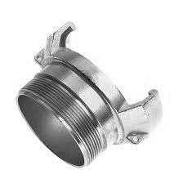

|  |  |  |  |  |  |
| --- | --- | --- | --- | --- | --- |
|  |  | ALUMINIO | | INOX 316 | |
| **DN 20** | **¾”** | *30104AL020* | **4.25** |  |  |
| **DN 25** | **1”** | *30104AL025* | **4.25** | *30104IN025* | **10.00** |
| **DN 32** | **1 ¼”** | *30104AL032* | **5.09** | *30104IN032* | **14.69** |
| **DN 40** | **1 ½”** | *30104AL040* | **5.32** | *30104IN040* | **16,01** |
| **DN 50** | **2”** | *30104AL050* | **6.75** | *30104IN050* | **27,08** |
| **DN 65** | **2 ½”** | *30104AL065* | **9.53** | *30104IN065* | **33.33** |
| **DN 80** | **3”** | *30104AL080* | **11.61** | *30104IN080* | **52.08** |
| **DN 100** | **4”** | *30104AL100* | **15.25** | *30104IN100* | **68.75** |

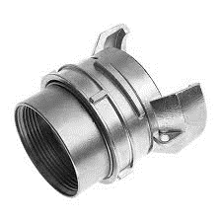

|  |  |  |  |  |  |  |  |
| --- | --- | --- | --- | --- | --- | --- | --- |
|  |  | ALUMINIO | | INOX 316 | | POLIPROP. | |
| **DN 25** | **1”** | *30105AL025* | **5.36** | *30105IN025* | **24.24** |  |  |
| **DN 32** | **1 ¼”** | *30105AL032* | **11.61** | *30105IN032* | **27.41** |  |  |
| **DN 40** | **1 ½”** | *30105AL040* | **12.36** | *30105IN040* | **43.75** | *30105PP040* | **13.52** |
| **DN 50** | **2”** | *30105AL050* | **17.94** | *30105IN050* | **43.75** | *30105PP050* | **18.44** |
| **DN 65** | **2 ½”** | *30105AL065* | **24.11** | *30105IN065* | **60.41** |  |  |
| **DN 80** | **3”** | *30105AL080* | **25.77** | *30105IN080* | **89.58** | *30105PP080* | **22.07** |
| **DN 100** | **4”** | *30105AL100* | **40.14** | *30105IN100* | **152.12** |  |  |

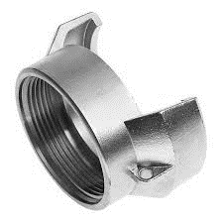

|  |  |  |  |  |  |
| --- | --- | --- | --- | --- | --- |
|  |  | ALUMINIO | | INOX 316 | |
| **DN 25** | **1”** | *30106AL025* | **4.25** | *30106IN025* | **9.02** |
| **DN 32** | **1 ¼”** | *30106AL032* | **5.50** | *30106IN032* | **15.41** |
| **DN 40** | **1 ½”** | *30106AL040* | **5.58** | *30106IN040* | **20.83** |
| **DN 50** | **2”** | *30106AL050* | **6.15** | *30106IN050* | **22.92** |
| **DN 65** | **2 ½”** | *30106AL065* | **8.34** | *30106IN065* | **31.25** |
| **DN 80** | **3”** | *30106AL080* | **13.14** | *30106IN080* | **52.08** |
| **DN 100** | **4”** | *30106AL100* | **16.89** | *30106IN100* | **53.58** |

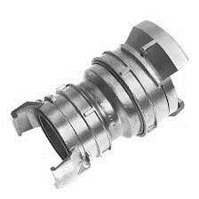

|  |  |  |  |  |  |  |  |
| --- | --- | --- | --- | --- | --- | --- | --- |
|  |  | ALUMINIO | | INOX 316 | | POLIPROP. | |
| **DN 65** | **DN 50** | *30102AL-04* | **29.97** | *30102IN-04* | **C** |  |  |
| **DN 80** | **DN 50** | *30102AL-05* | **46.48** | *30102IN-05* | **147.28** | *30102PP-* | **41.76** |
| **DN 80** | **DN 65** | *30102AL-06* | **41.22** | *30102IN-06* | **C** |  |  |
| **DN 100** | **DN 50** | *30102AL-07* | **C** | *30102IN-07* |  |  |  |
| **DN 100** | **DN 80** | *30102AL-09* | **68.55** | *30102IN-09* | **215.12** |  |  |

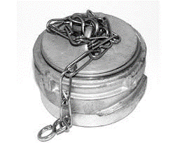

|  |  |  |  |  |
| --- | --- | --- | --- | --- |
|  | ALUMINIO | | INOX 316 | |
| **DN 40** | *30107AL040* | **8.26** | *30107IN040* | **21.11** |
| **DN 50** | *30107AL050* | **10.63** | *30107IN050* | **27.51** |
| **DN 65** | *30107AL065* | **12.64** | *30107IN065* | **37.90** |
| **DN 80** | *30107AL080* | **16.78** | *30107IN080* | **55.86** |
| **DN 100** | *30107AL100* | **21,65** | *30107IN100* | **94.34** |

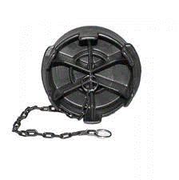

|  |  |  |  |  |  |  |
| --- | --- | --- | --- | --- | --- | --- |
|  | ALUMINIO | | INOX 316 | | POLIPROP. | |
| **DN 50** | *30108AL050* | **9.42** | *30108IN050* | **20.25** | *30108PP050* | **12.05** |
| **DN 80** | *30108AL080* | **13.17** | *30108IN080* | **30.14** | *30108PP080* | **12.46** |
| **DN 80** |  |  |  |  | *30108PP075* | **11.32** |
| **DN 100** |  |  |  |  | *30108PP100* | **15.18** |

***(30108PP080) .- Cadena de acero inoxidable (30108PP075) .- Cadena de plástico***

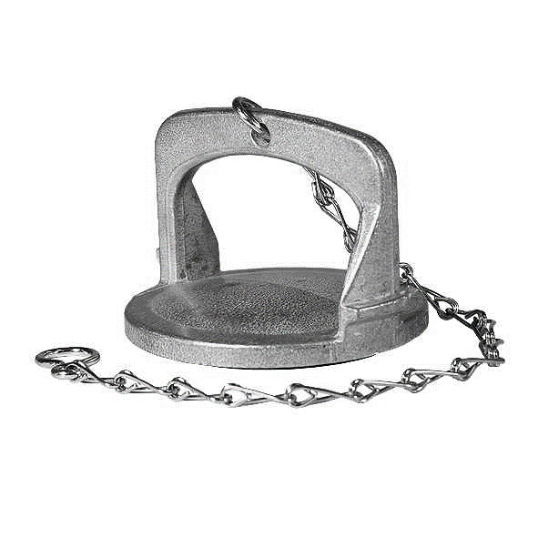

|  |  |  |
| --- | --- | --- |
|  | ALUMINIO | |
| **DN 80** | *30109AL080* | **10.94** |

|  |  |  |  |  |  |  |  |  |
| --- | --- | --- | --- | --- | --- | --- | --- | --- |
|  | N B R | | E P D M (bl) | | VITÓN | | TEFLON | |
| **DN 20** | *30110NB020* | **0.19** | *30110EP020* | **0.94** | *30110VT020* | **2.14** |  |  |
| **DN 25** | *30110NB025* | **0.24** | *30110EP025* | **0.81** | *30110VT025* | **2.91** |  |  |
| **DN 32** | *30110NB032* | **0.29** | *30110EP032* | **0.88** |  |  |  |  |
| **DN 40** | *30110NB040* | **0.47** | *30110EP040* | **0.94** | *30110EVT040* | **4.10** |  |  |
| **DN 50** | *30110NB050* | **0.66** | *30110EP050* | **1.13** | *30110VT050* | **7.09** | *30110TF050* | **0,95** |
| **DN 65** | *30110NB065* | **0.71** | *30110EP065* | **1.57** | *30110VT065* | **8.95** |  |  |
| **DN 80** | *30110NB080* | **1.18** | *30110EP080* | **2.00** | *30110VT080* | **10.57** | *30110TF080* | **1.58** |
| **DN 100** | *30110NB100* | **1.88** | *30110EP100* | **2.64** | *30110VT100* | **15.19** |  |  |

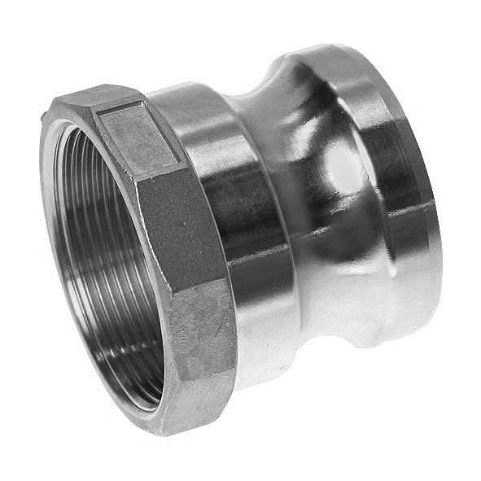

|  |  |  |  |  |  |  |  |  |
| --- | --- | --- | --- | --- | --- | --- | --- | --- |
|  | ALUMINIO | | INOX 316 | | LATÓN | | POLIPROP. | |
| **½”** | *30201AL013* | **2.29** | *30201IN013* | **5.50** | *30201LT013* | **4.46** | *30201PP013* | **1.76** |
| **¾”** | *30201AL019* | **1.99** | *30201IN019* | **7.65** | *30201LT019* | **5.58** | *30201PP019* | **1.04** |
| **1”** | *30201AL025* | **2.85** | *30201IN025* | **10.07** | *30201LT025* | **7.05** | *30201PP025* | **1.17** |
| **1 ¼”** | *30201AL032* | **3.42** | *30201IN032* | **15.51** | *30201LT032* | **12.19** | *30201PP032* | **1.95** |
| **1 ½”** | *30201AL040* | **3.85** | *30201IN040* | **20.61** | *30201LT040* | **16.43** | *30201PP040* | **1.69** |
| **2”** | *30201AL050* | **4.69** | *30201IN050* | **26.18** | *30201LT050* | **20.53** | *30201PP050* | **2.29** |
| **2 ½”** | *30201AL063* | **7.74** | *30201IN063* | **50.76** | *30201LT063* | **39.69** |  |  |
| **3”** | *30201AL075* | **8.55** | *30201IN075* | **56.04** | *30201LT075* | **42.50** | *30201PP075* | **5.96** |
| **4”** | *30201AL100* | **14.82** | *30201IN100* | **91.24** | *30201LT100* | **62.55** | *30201PP100* | **8.38** |
| **5”** | *30201AL125* | **22.91** | *30201IN125* | **129.46** | *30201LT125* | **93.71** |  |  |
| **6”** | *30201AL150* | **30.05** | *30201IN150* | **197.98** | *30201LT150* | **141.92** |  |  |
| **8”** | *30201AL200* | **98.65** |  |  |  |  |  |  |

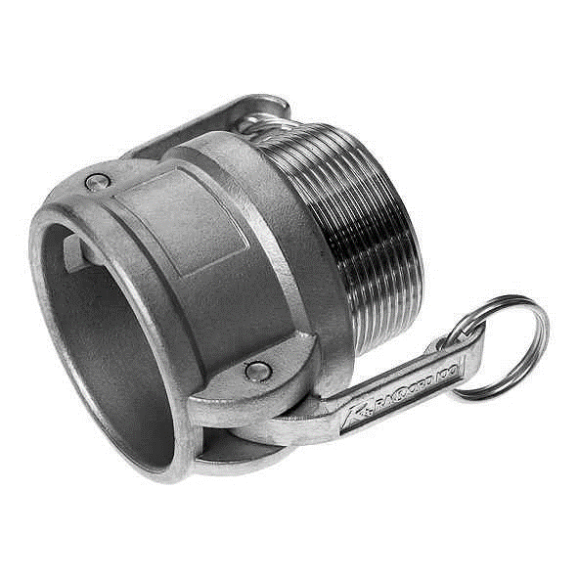

|  |  |  |  |  |  |  |  |  |
| --- | --- | --- | --- | --- | --- | --- | --- | --- |
|  | ALUMINIO | | INOX 316 | | LATÓN | | POLIPROP. | |
| **½”** | *30202AL013* | **4.20** | *30202IN013* | **12.23** | *30202LT013* |  | *30202PP013* | **7.51** |
| **¾”** | *30202AL019* | **4.46** | *30202IN019* | **15.00** | *30202LT019* | **10.27** | *30202PP019* | **4.92** |
| **1”** | *30202AL025* | **6.87** | *30202IN025* | **17.54** | *30202LT025* | **14.11** | *30202PP025* | **5.66** |
| **1 ¼”** | *30202AL032* | **9.90** | *30202IN032* | **26.27** | *30202LT032* | **19.60** | *30202PP032* | **11.66** |
| **1 ½”** | *30202AL040* | **10.50** | *30202IN040* | **28.39** | *30202LT040* | **26.30** | *30202PP040* | **8.77** |
| **2”** | *30202AL050* | **12.06** | *30202IN050* | **38.76** | *30202LT050* | **30.76** | *30202PP050* | **9.16** |
| **2 ½”** | *30202AL063* | **13.27** | *30202IN063* | **54.17** | *30202LT063* | **44.64** |  |  |
| **3”** | *30202AL075* | **17.76** | *30202IN075* | **69.51** | *30202LT075* | **55.71** | *30202PP075* | **17.02** |
| **4”** | *30202AL100* | **24.41** | *30202IN100* | **113.66** | *30202LT100* | **81.78** | *30202PP100* | **30.76** |
| **5”** | *30202AL125* | **34.46** | *30202IN125* | **179.95** | *30202LT125* | **112.45** |  |  |
| **6”** | *30202AL150* | **50.71** | *30202IN150* | **269.94** | *30202LT150* | **175.75** |  |  |
|  |  |  |  |  |  |  |  |  |

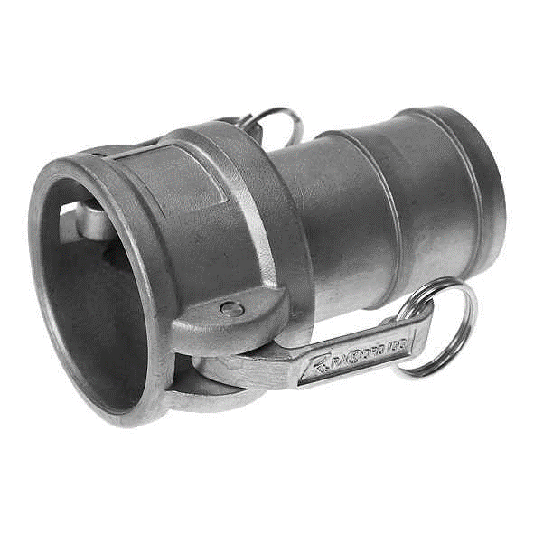

|  |  |  |  |  |  |  |  |  |
| --- | --- | --- | --- | --- | --- | --- | --- | --- |
|  | ALUMINIO | | INOX 316 | | LATÓN | | POLIPROP. | |
| **½”** | *30203AL013* | **5.10** | *30203IN013* | **11.43** | *30203LT013* | **9.25** | *30203PP013* | **7.76** |
| **¾”** | *30203AL019* | **5.10** | *30203IN019* | **15.23** | *30203LT019* | **10.98** | *30203PP019* | **5.36** |
| **1”** | *30203AL025* | **7.65** | *30203IN025* | **18.14** | *30203LT025* | **15.27** | *30203PP025* | **5.66** |
| **1 ¼”** | *30203AL032* | **10.20** | *30203IN032* | **26.61** | *30203LT032* | **24.96** | *30203PP032* | **8.90** |
| **1 ½”** | *30203AL040* | **11.45** | *30203IN040* | **29.94** | *30203LT040* | **27.68** | *30203PP040* | **9.68** |
| **2”** | *30203AL050* | **14.86** | *30203IN050* | **38.67** | *30203LT050* | **36.34** | *30203PP050* | **9.50** |
| **2 ½”** | *30203AL063* | **16.20** | *30203IN063* | **54.65** | *30203LT063* | **56.42** |  |  |
| **3”** | *30203AL075* | **21.82** | *30203IN075* | **78.41** | *30203LT075* | **79.15** | *30203PP075* | **17.59** |
| **4”** | *30203AL100* | **27.00** | *30203IN100* | **118.45** | *30203LT100* | **117.14** | *30203PP100* | **33.48** |
| **5”** | *30203AL125* | **43.75** | *30203IN125* | **196.91** | *30203LT125* | **153.74** |  |  |
| **6”** | *30203AL150* | **69.10** | *30203IN150* | **286.01** | *30203LT150* | **232.93** |  |  |
|  |  |  |  |  |  |  |  |  |

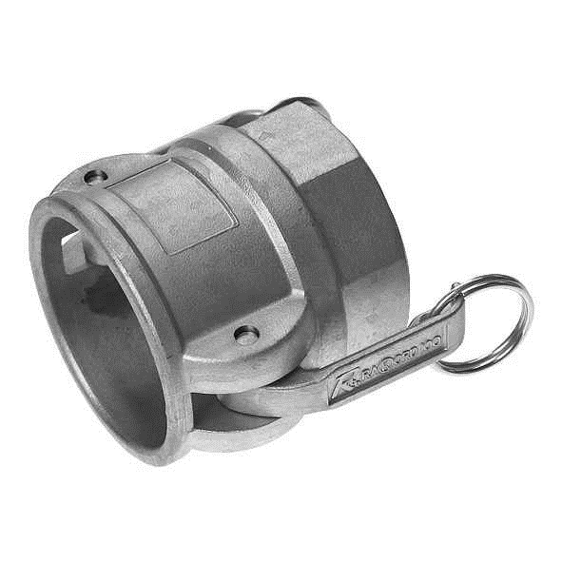

|  |  |  |  |  |  |  |  |  |
| --- | --- | --- | --- | --- | --- | --- | --- | --- |
|  | ALUMINIO | | INOX 316 | | LATÓN | | POLIPROP. | |
| **½”** | *30204AL013* | **6.10** | *30204IN013* | **12.86** | *30204LT013* | **9.25** | *30204PP013* | **9.26** |
| **¾”** | *30204AL019* | **6.10** | *30204IN019* | **15.00** | *30204LT019* | **11.34** | *30204PP019* | **6.13** |
| **1”** | *30204AL025* | **5.66** | *30204IN025* | **19.40** | *30204LT025* | **14.87** | *30204PP025* | **5.70** |
| **1 ¼”** | *30204AL032* | **9.55** | *30204IN032* | **27.22** | *30204LT032* | **22.37** | *30204PP032* | **9.34** |
| **1 ½”** | *30204AL040* | **10.93** | *30204IN040* | **30.29** | *30204LT040* | **26.69** | *30204PP040* | **8.86** |
| **2”** | *30204AL050* | **13.08** | *30204IN050* | **39.27** | *30204LT050* | **33.21** | *30204PP050* | **9.33** |
| **2 ½”** | *30204AL063* | **15.00** | *30204IN063* | **56.64** | *30204LT063* | **51.16** |  |  |
| **3”** | *30204AL075* | **19.32** | *30204IN075* | **69.95** | *30204LT075* | **63.08** | *30204PP075* | **14.95** |
| **4”** | *30204AL100* | **26.49** | *30204IN100* | **104.46** | *30204LT100* | **89.78** | *30204PP100* | **31.80** |
| **5”** | *30204AL125* | **34.46** | *30204IN125* | **145.40** | *30204LT125* | **136.69** |  |  |
| **6”** | *30204AL150* | **63.97** | *30204IN150* | **271.19** | *30204LT150* | **180.13** |  |  |
| **8”** | *30204AL200* | **206.11** |  |  |  |  |  |  |

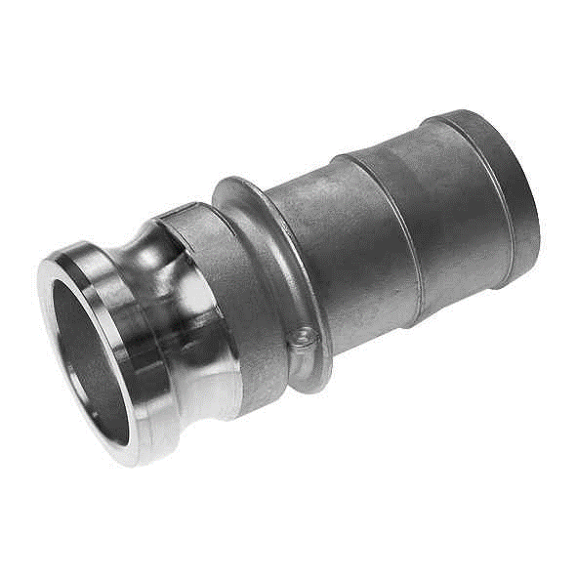

|  |  |  |  |  |  |  |  |  |
| --- | --- | --- | --- | --- | --- | --- | --- | --- |
|  | ALUMINIO | | INOX 316 | | LATÓN | | POLIPROP. | |
| **½”** | *30205AL013* | **2.29** | *30205IN013* | **4.82** | *30205LT013* | **4.82** | *30205PP013* | **1.76** |
| **¾”** | *30205AL019* | **2.37** | *30205IN019* | **8.21** | *30205LT019* | **8.48** | *30205PP019* | **1.08** |
| **1”** | *30205AL025* | **3.39** | *30205IN025* | **11.32** | *30205LT025* | **11.70** | *30205PP025* | **1.26** |
| **1 ¼”** | *30205AL032* | **4.58** | *30205IN032* | **17.88** | *30205LT032* | **18.48** | *30205PP032* | **1.56** |
| **1 ½”** | *30205AL040* | **5.14** | *30205IN040* | **24.67** | *30205LT040* | **25.49** | *30205PP040* | **1.79** |
| **2”** | *30205AL050* | **7.37** | *30205IN050* | **36.89** | *30205LT050* | **38.12** | *30205PP050* | **3.59** |
| **2 ½”** | *30205AL063* | **10.59** | *30205IN063* | **43.20** | *30205LT063* | **44.64** |  |  |
| **3”** | *30205AL075* | **13.53** | *30205IN075* | **72.32** | *30205LT075* | **74.73** | *30205PP075* | **6.13** |
| **4”** | *30205AL100* | **20.96** | *30205IN100* | **115.39** | *30205LT100* | **119.24** | *30205PP100* | **12.79** |
| **5”** | *30205AL125* | **32.99** | *30205IN125* | **172.58** | *30205LT125* | **172.58** |  |  |
| **6”** | *30205AL150* | **53.84** | *30205IN150* | **262.53** | *30205LT150* | **262.53** |  |  |
| **8”** | *30205AL200* | **170.08** |  |  |  |  |  |  |

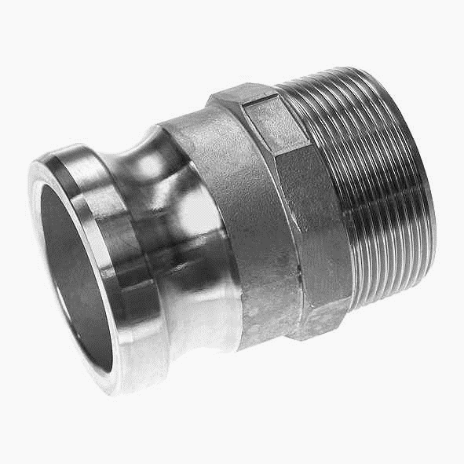

|  |  |  |  |  |  |  |  |  |
| --- | --- | --- | --- | --- | --- | --- | --- | --- |
|  | ALUMINIO | | INOX 316 | | LATÓN | | POLIPROP. | |
| **½”** | *30206AL013* | **2.33** | *30206IN013* | **6.12** | *30206LT013* | **5.14** | *30206PP013* | **2.24** |
| **¾”** | *30206AL019* | **2.41** | *30206IN019* | **8.12** | *30206LT019* | **6.25** | *30206PP019* | **1.12** |
| **1”** | *30206AL025* | **3.26** | *30206IN025* | **11.15** | *30206LT025* | **9.11** | *30206PP025* | **1.25** |
| **1 ¼”** | *30206AL032* | **4.45** | *30206IN032* | **18.92** | *30206LT032* | **12.82** | *30206PP032* | **2.05** |
| **1 ½”** | *30206AL040* | **5.50** | *30206IN040* | **23.46** | *30206LT040* | **18.62** | *30206PP040* | **1.79** |
| **2”** | *30206AL050* | **6.70** | *30206IN050* | **35.34** | *30206LT050* | **26.92** | *30206PP050* | **2.95** |
| **2 ½”** | *30206AL063* | **10.59** | *30206IN063* | **54.52** | *30206LT063* | **41.21** |  |  |
| **3”** | *30206AL075* | **13.79** | *30206IN075* | **71.76** | *30206LT075* | **53.75** | *30206PP075* | **5.54** |
| **4”** | *30206AL100* | **25.19** | *30206IN100* | **120.32** | *30206LT100* | **93.21** | *30206PP100* | **11.16** |
| **5”** | *30206AL125* | **32.59** | *30206IN125* | **128.38** | *30206LT125* | **138.88** |  |  |
| **6”** | *30206AL150* | **50.26** | *30206IN150* | **244.98** | *30206LT150* | **174.99** |  |  |
| **8”** | *30206AL200* | **140.93** |  |  |  |  |  |  |

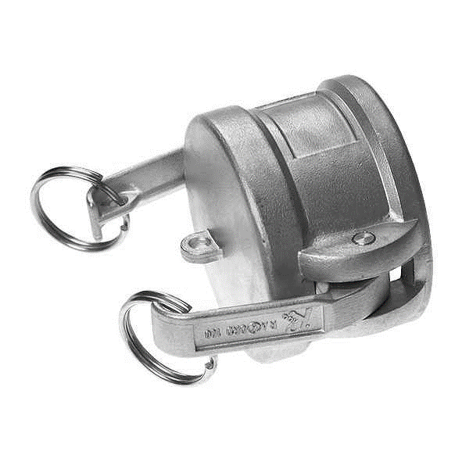

|  |  |  |  |  |  |  |  |  |
| --- | --- | --- | --- | --- | --- | --- | --- | --- |
|  | ALUMINIO | | INOX 316 | | LATÓN | | POLIPROP. | |
| **½”** | *30207AL013* | **3.68** | *30207IN013* | **10.71** | *30207LT013* | **8.00** | *30207PP013* | **4.67** |
| **¾”** | *30207AL019* | **4.64** | *30207IN019* | **12.10** | *30207LT019* | **8.12** | *30207PP019* | **5.32** |
| **1”** | *30207AL025* | **5.65** | *30207IN025* | **14.64** | *30207LT025* | **11.30** | *30207PP025* | **5.62** |
| **1 ¼”** | *30207AL032* | **7.19** | *30207IN032* | **21.95** | *30207LT032* | **18.71** | *30207PP032* | **8.90** |
| **1 ½”** | *30207AL040* | **8.54** | *30207IN040* | **25.45** | *30207LT040* | **21.43** | *30207PP040* | **8.73** |
| **2”** | *30207AL050* | **9.29** | *30207IN050* | **32.53** | *30207LT050* | **28.53** | *30207PP050* | **9.47** |
| **2 ½”** | *30207AL063* | **11.55** | *30207IN063* | **40.00** | *30207LT063* | **33.17** |  |  |
| **3”** | *30207AL075* | **14.29** | *30207IN075* | **57.28** | *30207LT075* | **45.44** | *30207PP075* | **12.84** |
| **4”** | *30207AL100* | **20.68** | *30207IN100* | **77.59** | *30207LT100* | **82.28** | *30207PP100* | **30.59** |
| **5”** | *30207AL125* | **20.49** | *30207IN125* | **146.15** | *30207LT125* | **99.28** |  |  |
| **6”** | *30207AL150* | **28.80** | *30207IN150* | **236.91** | *30207LT150* | **137.01** |  |  |
| **8”** | *30207AL200* | **101.51** |  |  |  |  |  |  |

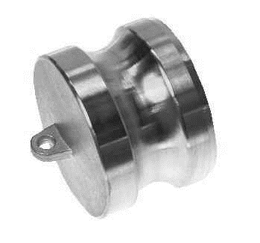

|  |  |  |  |  |  |  |  |  |
| --- | --- | --- | --- | --- | --- | --- | --- | --- |
|  | ALUMINIO | | INOX 316 | | LATÓN | | POLIPROP. | |
| **½”** | *30208AL013* | **1.40** | *30208IN013* | **3.30** | *30208LT013* | **3.17** | *30208PP013* | **0.78** |
| **¾”** | *30208AL019* | **1.84** | *30208IN019* | **4.41** | *30208LT019* | **3.98** | *30208PP019* | **1.04** |
| **1”** | *30208AL025* | **2.54** | *30208IN025* | **6.48** | *30208LT025* | **6.12** | *30208PP025* | **1.08** |
| **1 ¼”** | *30208AL032* | **2.72** | *30208IN032* | **11.84** | *30208LT032* | **6.12** | *30208PP032* | **1.86** |
| **1 ½”** | *30208AL040* | **3.07** | *30208IN040* | **14.30** | *30208LT040* | **12.59** | *30208PP040* | **1.38** |
| **2”** | *30208AL050* | **4.60** | *30208IN050* | **21.99** | *30208LT050* | **17.23** | *30208PP050* | **2.59** |
| **2 ½”** | *30208AL063* | **6.57** | *30208IN063* | **29.77** | *30208LT063* | **25.67** |  |  |
| **3”** | *30208AL075* | **8.02** | *30208IN075* | **42.68** | *30208LT075* | **35.76** | *30208PP075* | **4.23** |
| **4”** | *30208AL100* | **12.80** | *30208IN100* | **64.24** | *30208LT100* | **61.03** | *30208PP100* | **7.78** |
| **5”** | *30208AL125* | **C** | *30208IN125* | **99.78** | *30208LT125* | **90.49** |  |  |
| **6”** | *30208AL150* | **C** | *30208IN150* | **171,74** | *30208LT150* | **124.01** |  |  |
| **8”** | *30208AL200* | **C** |  |  |  |  |  |  |



* JUNTA DE TEFLON

|  |  |  |
| --- | --- | --- |
|  | INOX 316 | |
| **¾”** | *30211IN019* | **13.80** |
| **1”** | *30211IN025* | **18.55** |
| **1 ¼”** | *30211IN032* | **23.59** |
| **1 ½”** | *30211IN040* | **31.62** |
| **2”** | *30211IN050* | **41.52** |
| **2 ½”** | *30211IN063* | **57.47** |
| **3”** | *30211IN075* | **77.33** |
| **4”** | *30211IN100* | **106.26** |

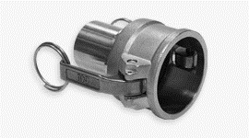

* CAÑA LISA PARA MANGUERA

|  |  |  |
| --- | --- | --- |
|  | INOX 316 | |
| **¾”** | *30213IN019* | **18.80** |
| **1”** | *30213IN025* | **24.89** |
| **1 ¼”** | *30213IN032* | **35.02** |
| **1 ½”** | *30213IN040* | **39.34** |
| **2”** | *30213IN050* | **53.35** |
| **2 ½”** | *30213IN063* | **71.68** |
| **3”** | *30213IN075* | **94.58** |
| **4”** | *30213IN100* | **139.44** |



* JUNTA DE TEFLON

|  |  |  |
| --- | --- | --- |
|  | INOX 316 | |
| **¾”** | *30214IN019* | **21.24** |
| **1”** | *30214IN025* | **27.75** |
| **1 ¼”** | *30214IN032* | **40.06** |
| **1 ½”** | *30214IN040* | **43.21** |
| **2”** | *30214IN050* | **54.10** |
| **2 ½”** | *30214IN063* | **73.58** |
| **3”** | *30214IN075* | **95.55** |
| **4”** | *30214IN100* | **140.65** |

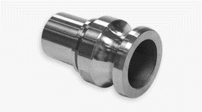

* CAÑA LISA PARA MANGUERA

|  |  |  |
| --- | --- | --- |
|  | INOX 316 | |
| **¾”** | *30215IN019* | **14.28** |
| **1”** | *30215IN025* | **19.10** |
| **1 ¼”** | *30215IN032* | **22.75** |
| **1 ½”** | *30215IN040* | **31.30** |
| **2”** | *30215IN050* | **42.26** |
| **2 ½”** | *30215IN063* | **61.92** |
| **3”** | *30215IN075* | **84.85** |
| **4”** | *30215IN100* | **146.79** |

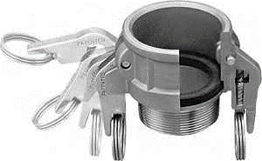

|  |  |  |  |  |  |  |  |  |
| --- | --- | --- | --- | --- | --- | --- | --- | --- |
|  | SAFLOCK “B” | | SAFLOCK “C”  (caña lisa) | | SAFLOCK “D” | | SAFLOCK “DC” | |
|  | INOX 316 | | INOX 316 | | INOX 316 | | INOX 316 | |
| **¾”** | *30222IN019* | **89.41** | *30223IN019* | **85.91** | *30224IN019* | **99.29** | *30227IN019* | **78.62** |
| **1”** | *30222IN025* | **95.25** | *30223IN025* | **93.52** | *30224IN025* | **105.58** | *30227IN025* | **81.32** |
| **1 ¼”** | *30222IN032* | **112.77** | *30223IN032* | **C** | *30224IN032* | **125.35** | *30227IN032* | **91.65** |
| **1 ½”** | *30222IN040* | **129.39** | *30223IN040* | **107.84** | *30224IN040* | **143.77** | *30227IN040* | **95.25** |
| **2”** | *30222IN050* | **133.44** | *30223IN050* | **119.19** | *30224IN050* | **159.50** | *30227IN050* | **107.83** |
| **2 ½”** | *30222IN063* | **179.28** | *30223IN063* | **187.47** | *30224IN063* | **218.35** | *30227IN063* | **134.78** |
| **3”** | *30222IN075* | **215.65** | *30223IN075* | **228.42** | *30224IN075* | **282.15** | *30227IN075* | **163.99** |

|  |  |  |  |  |  |  |  |  |
| --- | --- | --- | --- | --- | --- | --- | --- | --- |
|  | N B R | | E P D M | | VITÓN | | SANWICH  VITÓN + PTFE | |
| **½”** | *30209NB013* | **0.19** | *30209EP013* | **0.24** | *30209VT013* | **0.95** |  |  |
| **¾”** | *30209NB019* | **0.24** | *30209EP019* | **0.29** | *30209VT019* | **2.09** |  |  |
| **1”** | *30209NB025* | **0.29** | *30209EP025* | **0.34** | *30209VT025* | **2.81** | *30209VP025* | **5,04** |
| **1 ¼”** | *30209NB032* | **0.34** | *30209EP032* | **0,43** | *30209VT032* | **4.05** | *30209VP032* | **8,38** |
| **1 ½”** | *30209NB040* | **0.43** | *30209EP040* | **0.58** | *30209VT040* | **4.52** | *30209VP040* | **11.53** |
| **2”** | *30209NB050* | **0.53** | *30209EP050* | **0.90** | *30209VT050* | **5.85** | *30209VP050* | **14.24** |
| **2 ½”** | *30209NB063* | **0.76** | *30209EP063* | **1.09** | *30209VT063* | **8.71** | *30209VP063* | **18.71** |
| **3”** | *30209NB075* | **0.90** | *30209EP075* | **1.57** | *30209VT075* | **9.86** | *30209VP075* | **25.52** |
| **4”** | *30209NB100* | **1.33** | *30209EP100* | **2.09** | *30209VT100* | **16.43** | *30209VP100* | **30.85** |
| **5”** | *30209NB125* | **1.81** | *30209EP125* | **2.19** | *30209VT125* | **25.29** |  |  |
| **6”** | *30209NB150* | **2.28** | *30209EP150* | **2.52** | *30209VT150* | **32.48** |  |  |
| **8”** | *30209NB200* | **6.38** |  |  |  |  |  |  |

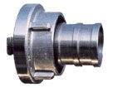

|  |  |  |  |  |
| --- | --- | --- | --- | --- |
| **D. I. manguera** | **Tipo de garra** | **Distancia garra** | ALUMINIO FORJADO | |
| **19 mm** | **25D** | **31 mm** | *30301019D* | **C** |
| **25 mm** | **25D** | **31 mm** | *30301025D* | **C** |
| **38 mm** | **52C** | **66 mm** | *30301038C* | **8.09** |
| **45 mm** | **52C** | **66 mm** | *30301045C* | **8.09** |
| **50 mm** | **52C** | **66 mm** | *30301052C* | **8.09** |
| **63 mm** | **65** | **81 mm** | *30301063* | **C** |
| **65 mm** | **75B** | **89 mm** | *30301065B* | **12.79** |
| **70 mm** | **75B** | **89 mm** | *30301070B* | **C** |
| **75 mm** | **75B** | **89 mm** | *30301075B* | **12.79** |
| **80 mm** | **75B** | **89 mm** | *30301080B* | **C** |
| **100 mm** | **110A** | **133 mm** | *30301100B* | **33.58** |
| **125 mm** |  | **148 mm** | *30301125* | **C** |
| **150 mm** |  | **160 mm** | *30301AL150* | **C** |

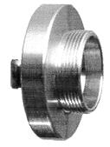

|  |  |  |  |  |
| --- | --- | --- | --- | --- |
| **Rosca** | **Tipo de garra** | **Distancia garra** | ALUMINIO FORJADO | |
| **¾”** | **25D** | **31 mm** | *30302019D* | **C** |
| **1”** | **25D** | **31 mm** | *30302025D* | **C** |
| **1 ½”** | **52C** | **66 mm** | *30302040C* | **8.03** |
| **2”** | **52C** | **66 mm** | *30302050C* | **7.50** |
| **2”** | **75B** | **89 mm** | *30302050B* | **C** |
| **2 ½”** | **75B** | **89 mm** | *30302063B* | **12.79** |
| **3”** | **75B** | **89 mm** | *30302075B* | **12.79** |
| **4”** | **110A** | **133 mm** | *30202100A* | **21.30** |
| **6”** |  |  | *30202150* | **C** |

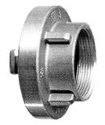

|  |  |  |  |  |
| --- | --- | --- | --- | --- |
| **Rosca** | **Tipo de garra** | **Distancia garra** | ALUMINIO FORJADO | |
| **¾”** | **25D** | **31 mm** | *30303019D* | **C** |
| **1”** | **25D** | **31 mm** | *30303025D* | **C** |
| **1 ½”** | **52C** | **66 mm** | *30303040C* | **8.03** |
| **2”** | **52C** | **66 mm** | *30303050C* | **7.50** |
| **2”** | **75B** | **89 mm** | *30303050B* | **C** |
| **2 ½”** | **75B** | **89 mm** | *30303063B* | **8.03** |
| **3”** | **75B** | **89 mm** | *30303075B* | **12.79** |
| **4”** | **110A** | **133 mm** | *30303100A* | **21.30** |
| **6”** |  | **160 mm** | *30303150* | **C** |

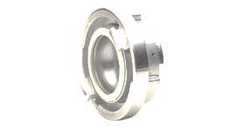

|  |  |  |  |
| --- | --- | --- | --- |
| **Tipo de garra** | **Tipo de garra** | ALUMINIO | |
| **52C** | **25D** | *30304C-D* | **C** |
| **75B** | **52C** | *30304B-C* | **40.48** |
| **110A** | **75B** | *30304A-B* | **24.52** |
| **125** | **110A** | *30304125-A* | **C** |
| **150** | **110A** | *30304150-A* | **C** |

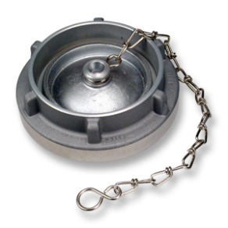

|  |  |  |  |
| --- | --- | --- | --- |
| **Tipo de garra** | **Distancia garra** | ALUMINIO | |
| **25D** | **31 mm** | *30305025D* | **C** |
| **52C** | **66 mm** | *30305050C* | **10.67** |
| **75B** | **81 mm** | *30305075B* | **14,38** |
| **110A** | **133 mm** | *30305100A* | **25.58** |
| **125** | **148 mm** | *30305125* | **C** |
| **150** | **160 mm** | *30305150* | **C** |

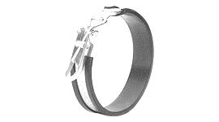

|  |  |
| --- | --- |
| **Tipo de garra** |  |
| **C** | **36.83** |
| **B** | **40.15** |
| **A** | **45.34** |

|  |  |
| --- | --- |
| **Tipo de garra** | N B R blanco |
| **25D** | **1.11** |
| **52C** | **1.58** |
| **75B** | **2.68** |
| **110A** | **5.98** |

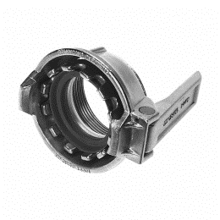

|  |  |  |  |  |  |
| --- | --- | --- | --- | --- | --- |
|  |  | LATÓN | | INOX 316 | |
| **MK 50** | **2”** | *30401LT050* | **35.06** | *30401IN050* | **40.06** |
| **MK 80** | **3”** | *30401LT080* | **65.10** | *30401IN080* | **80.13** |
| **MK 100** | **4”** | *30401LT100* | **164.34** | *30401IN100* | **179.32** |

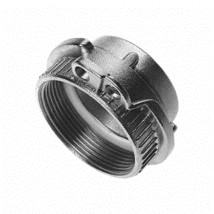

|  |  |  |  |  |  |
| --- | --- | --- | --- | --- | --- |
|  |  | LATÓN | | INOX 316 | |
| **VK 50** | **2”** | *30402LT050* | **15.70** | *30402IN050* | **18.78** |
| **VK 80** | **3”** | *30402LT080* | **30.90** | *30402IN080* | **35.66** |
| **VK 100** | **4”** | *30402LT100* | **54.64** | *30402IN100* | **65.61** |

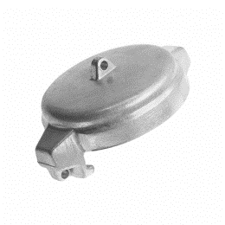

|  |  |  |  |  |  |  |
| --- | --- | --- | --- | --- | --- | --- |
|  | ALUMINIO | | INOX 316 | | LATÓN | |
| **MB 50** | *30403AL050* | **7.05** | *30403IN050* | **13.77** | *30403LT050* | **15.21** |
| **MB 80** | *30403AL080* | **14.16** | *30403IN080* | **36.93** | *30403LT080* | **36.31** |
| **MB100** | *30403AL100* | **29.60** | *30403IN100* | **75.12** | *30403LT100* | **62.60** |

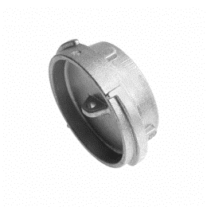

|  |  |  |  |  |  |  |
| --- | --- | --- | --- | --- | --- | --- |
|  | ALUMINIO | | INOX 316 | | LATÓN | |
| **VB 50** | *30404AL050* | **5.62** | *30404IN050* | **14.40** | *30404LT050* | **13.77** |
| **VB 80** | *30404AL080* | **10.58** | *30404IN080* | **38.81** | *30404LT080* | **31.30** |
| **VB 100** | *30404AL100* | **23.26** | *30404IN100* | **60.34** | *30404LT100* | **45.07** |

|  |  |  |  |  |  |  |  |
| --- | --- | --- | --- | --- | --- | --- | --- |
|  |  | N B R | | HYPALON | | VITÓN | |
| **LABIO** | **MK 50** | *30405NB050* | **1.77** | *30405HP050* | **2.09** | *30405VT050* | **15,81** |
| **MK 80** | *30405NB080* | **2.52** | *30405HP080* | **3.23** | *30405VT080* | **22.57** |
| **TÓRICA** | **MK 100** | *30405NB100* | **8.00** | *30405HP100* | **12.76** | *30405VT100* | **C** |

|  |  |  |  |  |  |
| --- | --- | --- | --- | --- | --- |
|  |  | TEFLON | | VULKOLLAN | |
| **FONDO** | **50** | *30406TF050* | **1.07** | *30406VL050* | **1.00** |
| **DE** | **80** | *30406TF080* | **1.45** | *30406VL080* | **1.24** |
| **ROSCA** | **100** |  |  | *30406VL100* | **2.61** |

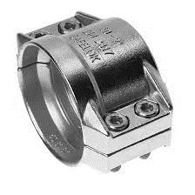

|  |  |  |  |  |  |
| --- | --- | --- | --- | --- | --- |
|  |  | ALUMINIO | | INOX 316 | |
| **13 X 5** | **22 – 24** | *30407AL13* | **6.92** | *30407IN13* | **13.93** |
| **19 X 6** | **30 – 33** | *30407AL19* | **7.23** | *30407IN19* | **16.81** |
| **25 X 6** | **36 – 39** | *30407AL25* | **7.32** | *30407IN25* | **18.57** |
| **32 X 6** | **43 – 46** | *30407AL321* | **8.26** | *30407IN32* | **19.50** |
| **32 X 8** | **47 – 50** | *30407AL322* | **11.34** |  |  |
| **38 X 6.5** | **50 – 52** | *30407AL381* | **8.39** | *30407IN381* | **23.50** |
| **38 X 8** | **53 – 56** | *30407AL382* | **12.28** | *30407IN382* | **23.50** |
| **40 X 7** | **53 - 56** | *30407AL401* | **8.39** |  |  |
| **40 X 10** | **58 - 61** | *30407AL402* | **13.66** |  |  |
| **50 X 6** | **61 – 63** | *30407AL501* | **21.96** | *30407IN501* | **35.32** |
| **50 X 8** | **64 – 67** | *30407AL502* | **11.82** | *30407AL502* | **37.04** |
| **50 X 10** | **69 – 71** | *30407AL503* | **12.19** | *30407IN503* | **44.87** |
| **63 X 8** | **78 – 82** | *30407AL63* | **18.57** | *30407IN63* | **58.02** |
| **75 X 8** | **89 – 93** | *30407AL751* | **19.96** | *30407IN75* | **64.93** |
| **75 X 10** | **94 – 97** | *30407AL752* | **21.43** |  |  |
| **80 X 8** | **94 – 97** | *30407AL80* | **36.16** | *30407IN80* | **79.73** |
| **90 x 6,5** | **101 - 105** | *30407AL90* | **30.14** |  |  |
| **100 X 8** | **114 – 119** | *30407AL101* | **49.60** | *30407IN101* | **160.34** |
| **100 X 10** | **118 - 122** | *30407AL102* | **54.68** |  |  |

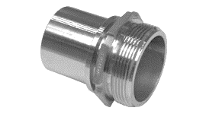

|  |  |  |  |  |  |
| --- | --- | --- | --- | --- | --- |
|  |  | LATÓN | | INOX 316 | |
| **½”** | **13 mm** | *30408LT013* | **C** | *30408IN013* | **C** |
| **¾”** | **19 mm** | *30408LT019* | **6.59** | *30408IN019* | **13.55** |
| **1”** | **25 mm** | *30408LT025* | **8.08** | *30408IN025* | **16.54** |
| **1 ¼”** | **32 mm** | *30408LT032* | **10.09** | *30408IN032* | **20.99** |
| **1 ½”** | **38 mm** | *30408LT038* | **14.31** | *30408IN381* | **26.59** |
| **2”** | **50 mm** | *30408LT050* | **20.45** | *30408IN050* | **29.75** |
| **2 ½”** | **63 mm** | *30408LT063* | **33.16** | *30408IN063* | **50.76** |
| **3”** | **75 mm** | *30408LT075* | **51.61** | *30408IN075* | **75.61** |
| **4”** | **100 mm** | *30408LT100* | **96.16** | *30408IN100* | **147.44** |

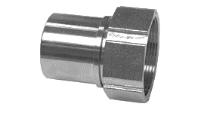

|  |  |  |  |  |  |
| --- | --- | --- | --- | --- | --- |
|  |  | LATÓN | | INOX 316 | |
| **½”** | **13 mm** | *30409LT013* | **C** | *30409IN013* | **C** |
| **¾”** | **19 mm** | *30409LT019* | **6.45** | *30409IN019* | **18.16** |
| **1”** | **25 mm** | *30409LT025* | **7.76** | *30409IN025* | **22.96** |
| **1 ¼”** | **32 mm** | *30409LT032* | **10.75** | *30409IN032* | **26.17** |
| **1 ½”** | **38 mm** | *30409LT038* | **15.49** | *30409IN038* | **33.37** |
| **2”** | **50 mm** | *30409LT050* | **24.63** | *30409IN050* | **46.03** |
| **2 ½”** | **63 mm** | *30409LT063* | **46.01** | *30409IN063* | **67.28** |
| **3”** | **75 mm** | *30409LT075* | **59.80** | *30409IN075* | **89.28** |
| **4”** | **100 mm** | *30409LT100* | **171.51** | *30409IN100* | **194.40** |

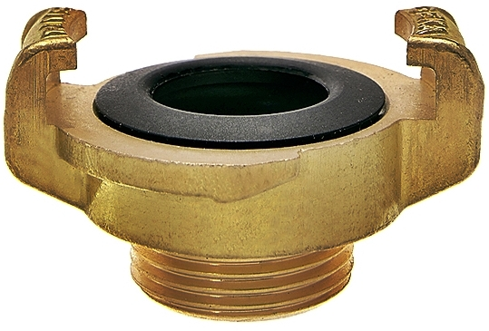

|  |  |  |  |  |
| --- | --- | --- | --- | --- |
|  | INOX 316 | | BRONCE | |
| **RM ½”** | *30602IN013* | **28.48** | *30601LT013* | **C** |
| **RM ¾”** | *30601IN019* | **28.48** | *30601LT019* | **C** |
| **RM 1”** | *30601IN025* | **28.48** | *30601LT025* | **C** |

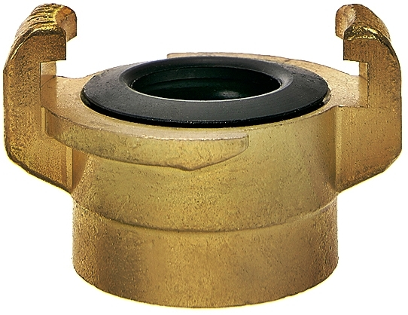

|  |  |  |  |  |
| --- | --- | --- | --- | --- |
|  | INOX 316 | | BRONCE | |
| **RH ½”** | *30603IN013* | **28.48** | *30603LT013* | **C** |
| **RH ¾”** | *30603IN019* | **28.48** | *30603LT019* | **C** |
| **RH 1”** | *30603IN025* | **28.48** | *30603LT025* | **C** |

|  |  |  |  |  |
| --- | --- | --- | --- | --- |
|  | INOX 316 | | BRONCE | |
| **Tapón** | *30604IN* | **28.48** | *30604LT* | **C** |

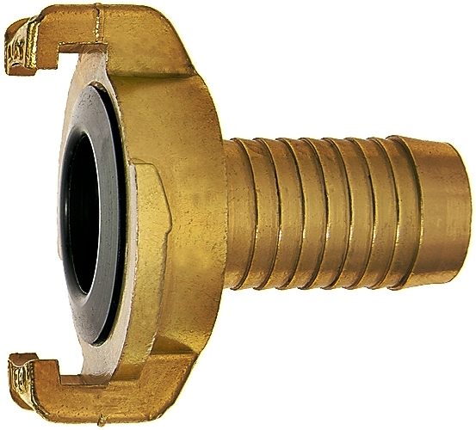

|  |  |  |  |
| --- | --- | --- | --- |
|  |  | LATÓN | |
| **½”** | **15 mm** | *30701LT015* | **3.28** |
| **¾”** | **19 mm** | *30701LT019* | **3.74** |
| **1”** | **25 mm** | *30701LT025* | **4.83** |



|  |  |  |
| --- | --- | --- |
|  | LATÓN | |
| **½”** | *30702LT013* | **3.40** |
| **¾”** | *30702LT019* | **3.51** |
| **1”** | *30702LT025* | **3.51** |



|  |  |  |
| --- | --- | --- |
|  | LATÓN | |
| **½”** | *30703LT013* | **3.51** |
| **¾”** | *30703LT019* | **3.51** |
| **1”** | *30703LT025* | **3.51** |

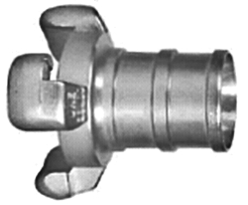

|  |  |  |  |  |  |
| --- | --- | --- | --- | --- | --- |
|  |  | ALUMINIO FUNDIDO | | ALUMINIO FORJADO | |
| **DN 25** | **PM 25** |  |  | *30801AE025* | **14.33** |
| **DN 45** | **PM 45** | *30801AF045* | **13.08** | *30801AE045* | **20.77** |
| **DN 70** | **PM 70** | *30801AF070* | **20.52** | *30801AE070* | **32.76** |
| **DN 100** | **PM 100** |  |  | *30801AE100* | **C** |

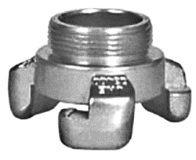

|  |  |  |  |  |  |
| --- | --- | --- | --- | --- | --- |
|  |  | ALUMINIO FUNDIDO | | ALUMINIO FORJADO | |
| **DN 25** | **1”** |  |  | *30802AE252* | **13.16** |
| **DN 45** | **1 ½”** | *30802AF045* | **11.89** | *30802AE045* | **17.26** |
| **DN 70** | **2 ½”** | *30802AF070* | **19.33** | *30802AE070* | **25.74** |
| **DN 100** | **4”** |  |  | *30802AE100* | **C** |

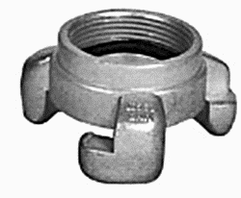

|  |  |  |  |  |  |
| --- | --- | --- | --- | --- | --- |
|  |  | ALUMINIO FUNDIDO | | ALUMINIO FORJADO | |
| **DN 25** | **1”** |  |  | *30803AE252* | **13.16** |
| **DN 45** | **1 ½”** | *30803AF045* | **12.79** | *30803AE045* | **16.67** |
| **DN 45** | **2”** |  |  | *30803AE451* | **36.56** |
| **DN 70** | **2 ½”** | *30803AF070* | **17.84** | *30803AE070* | **25.74** |
| **DN 100** | **4”** |  |  | *30803AE100* | **C** |

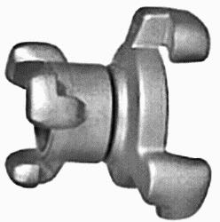

|  |  |  |  |  |  |
| --- | --- | --- | --- | --- | --- |
|  |  | ALUMINIO FUNDIDO | | ALUMINIO FORJADO | |
| **DN 45** | **DN 25** |  |  | *30804AE-1* | **31.88** |
| **DN 70** | **DN 45** | *30804AF-2* | **32.11** | *30804AE-2* | **42.41** |
| **DN 100** | **DN 70** |  |  | *30804AE-3* | **C** |

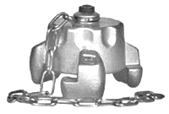

|  |  |  |  |  |
| --- | --- | --- | --- | --- |
|  | ALUMINIO FUNDIDO | | ALUMINIO FORJADO | |
| **DN 25** |  |  | *30805AE025* | **16.09** |
| **DN 45** | *30805AF045* | **15.46** | *30805AE045* | **21.35** |
| **DN 70** | *30805AF070* | **22.90** | *30805AE070* | **29.25** |
| **DN 100** |  |  | *30805AE100* | **C** |

|  |  |  |
| --- | --- | --- |
|  | N B R | |
| **DN 25** | *30806NB025* | **0.20** |
| **DN 45** | *30806NB045* | **0.40** |
| **DN 70** | *30806NB070* | **0.56** |

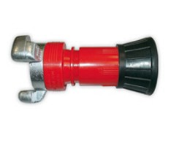

|  |  |  |
| --- | --- | --- |
|  | SIN RACOR HEMBRA | |
| **DN 25** | *30807SR025* | **8.80** |
| **DN 45** | *30807SR045* | **8.80** |
| **DN 70** | *30807SR070* | **16.00** |